Turkey Burn 2016
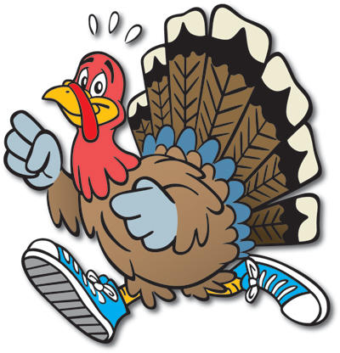

Please join us for our annual Free Family Zumba Night on November 17th from 6-7:30. We will be led by a certified Zumba instructor. Please bring a water bottle & join us for some Zumba fun!!

Turkey Burn 2016

Please join us for our annual Free Family Zumba Night on November 17th from 6-7:30. We will be led by a certified Zumba instructor. Please bring a water bottle & join us for some Zumba fun!!

